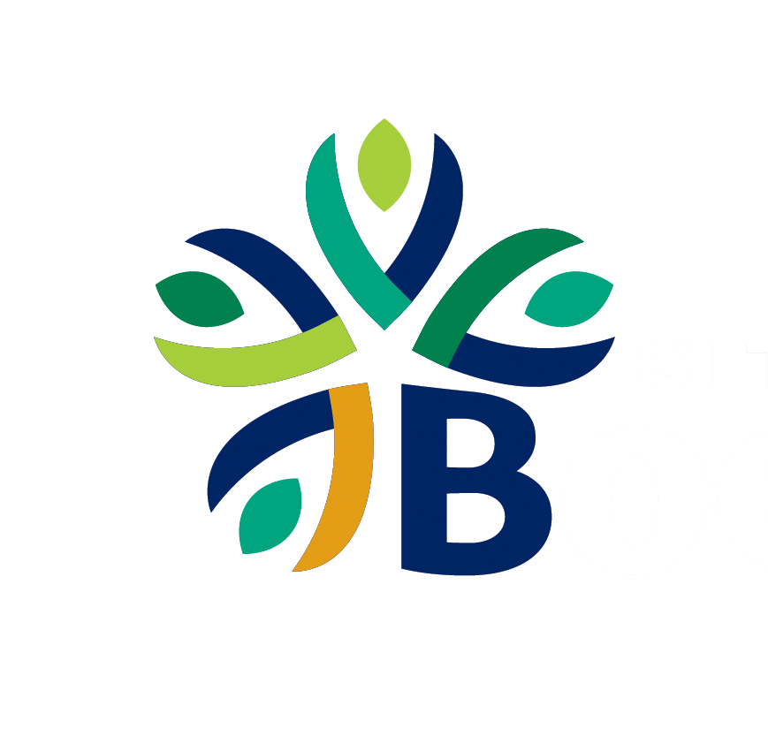 | AGENDA ITEM SUMMARY
Agenda Date | January 14, 2025
Requested Action | APPROVE resolution No. 2025-R04; a resolution authorizing the city manager to enter into and manage A Contract between the city of boerne and __________________________ as construction manager at risk for northside community park BOND improvements.
Contact Person | Lissette Jimenez, Director of Parks & Recreation
Background Information | Background:  On November 3, 2024, a Request for Proposals (RFP) for Construction Manager at Risk (CMAR) services for the Northside Community Park Bond Improvements was released. The deadline for proposals was November 22, 2024, at 2 p.m. A total of five proposals were received by the deadline, all of which appeared to meet the outlined requirements. Staff and the project team thoroughly reviewed all submitted proposals.  Evaluation Process:  Following the review process, three firms were selected for interviews:  - Waterman Construction  - Whiting Turner Contracting Co.  - Marksmen General Contractors, LLC.  The interviews were conducted on December 12, 2024, by staff members, the project lead design consultant, and Project Control staff.  Selection Criteria:  The selection process for the CMAR was based on the following criteria:  - Understanding of City’s Objectives (15%)  - Similar Facility Experience (20%)  - CMAR Experience (15%)  - Team Experience (20%)  - Pricing (30%)  Proposed Fee Structure:  The primary terms of the CMAR proposal include the following three fee services based on cost plus fee pricing with a guaranteed maximum:  - Pre-Construction Services: Covers personnel expenses, project estimates, preliminary project schedules, value engineering, constructability review, preplanning, and other related services.  - Construction Fee: This fee is a percentage of the construction budget covering other costs not included in the allowable General Overhead Fee, including overhead and profit.  - General Overhead Fees: Includes personnel costs, required bonds and insurance, site necessities, and field office necessities.  CMAR Contract Award and Cost:  Based on evaluation of the scoring proposal, interview results, and fee structure, the evaluation team recommends Council award the CMAR contract to Waterman Construction with the following fee breakdown:  - Pre-Construction Services Fee: $22,000  - CMAR Construction Fee: 2.66% of cost of work  - General Conditions & Insurance: $453,751  The Guaranteed Maximum Price of the project will be determined upon the completion of the project design and the estimation of probable construction costs.  Staff recommend that the City Council authorize the City Manager to enter into and manage a Construction Manager at Risk (CMAR) Contract with Waterman Construction for the Northside Community Park Bond Improvements.
Item Justification | [X] Legal/Regulatory Obligation  [ ] Reduce Costs  [ ] Increase Revenue  [X] Mitigate Risk  [X] Master Plan Recommendation | [X] Infrastructure Investment  [ ] Customer Pull  [ ] Service Enhancement  [X] Process Efficiency  [ ] Other:
Strategic Alignment | F2: Investing in and maintaining high-quality infrastructure.  B2: Advancing master plan recommendations.  B3: Providing streamlined and efficient processes.
Financial Considerations | The Northside Community Park Bond Project is a budgeted expense captured in the FY25 budget.
Citizen Input/Board Review | N/A
Legal Review | Legal has reviewed the CMAR Construction Agreement.
Alternative Options
Supporting Documents | Resolution No. 2025-R04  CMAR Proposal Matrix

