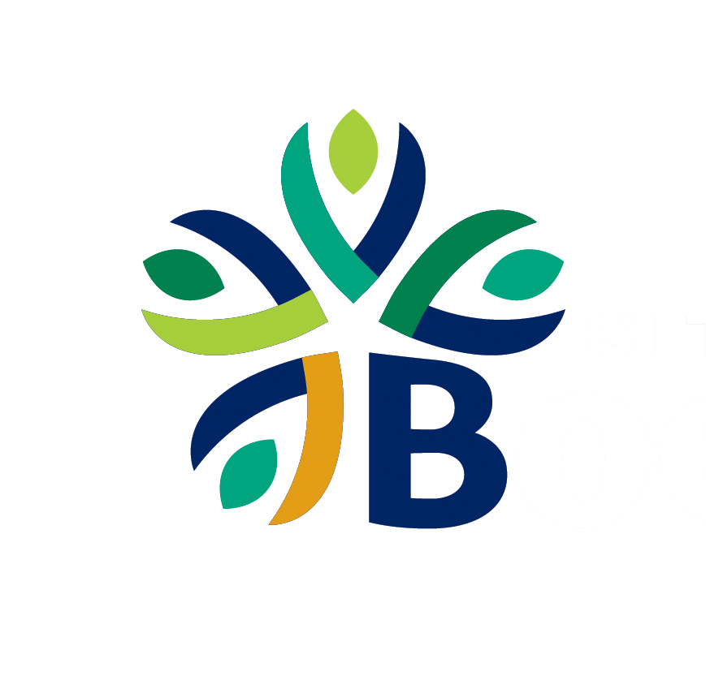 | AGENDA ITEM SUMMARY
Agenda Date | January 14, 2025
Requested Action | APPROVE RESOLUTION nO. 2025-R02; A RESOLUTION AUTHORIZING THE CITY MANAGER TO ENTER INTO AND MANAGE AN AGREEMENT BETWEEN THE CITY OF BOERNE AND FEDERAL HIGHWAY ADMINISTRATION (FHWA) FOR THE BRIDGE INVESTMENT PROGRAM (BIP) GRANT PROGRAM.
Contact Person | Jeffrey Carroll – Engineering & Mobility Director
Background Information | The Bridge Investment Program (BIP) was established under the Federal Bipartisan Infrastructure Law (BIL) with $80 million in appropriated funds over five years (2022–2026). The program aims to reduce the number of bridges in poor condition or at risk of falling into poor condition.  The City of Boerne applied for and was awarded a Planning Grant under the BIP. This grant supports the development of a comprehensive plan to address significant safety, transportation, and mobility challenges associated with 18 bridges located within the City. The plan will prioritize six bridges identified as being in "Fair" condition based on recent National Bridge Inventory (NBI) data.  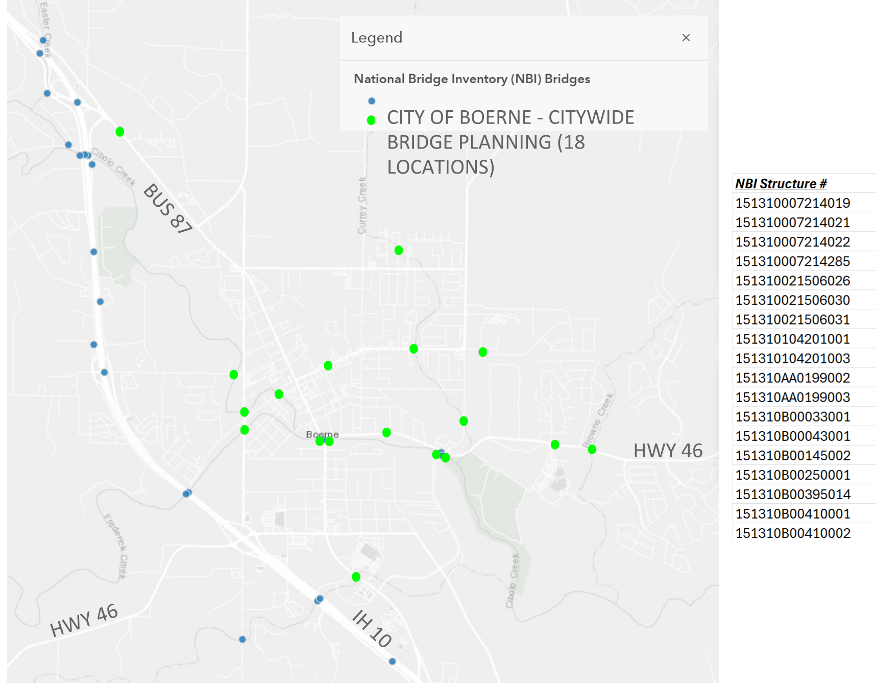  The total agreement amount is $750,000, consisting of $600,000 in FHWA funds and a $150,000 City match. To receive these funds, the City must enter into an agreement with the U.S. Department of Transportation (USDOT)/FHWA.  Currently, the City is accepting Statements of Qualification (SOQs) from engineering firms to provide professional consulting services for the FY 2025 BIP program. The SOQ submission deadline is January 16, 2025.
Item Justification | [ ] Legal/Regulatory Obligation  [X] Reduce Costs  [ ] Increase Revenue  [X] Mitigate Risk  [ ] Master Plan  Recommendation | [X] Infrastructure Investment  [ ] Customer Pull  [ ] Service Enhancement  [ ] Process Efficiency  [ ] Other:
Strategic Alignment | F2 – Investing in and maintaining high-quality infrastructure systems and public assets.  B1 – Utilizing data to drive smart decision making
Financial Considerations | The $750,000 project will be funded through $600,000 in federal funds (80%) and $150,000 in City funds (20%).
Citizen Input/Board Review | N/A
Legal Review | N/A
Alternative Options | N/A
Supporting Documents | Resolution No. 2025-R02  FHWA Agreement

